Practical 2 - Study Linux File System Hierarchy and Perform File/Directory Operations
1. Aim: -
To study the Linux file system hierarchy and perform basic file and directory operations using shell commands.
2. Requirements: -
Hardware:
- A computer/laptop with minimum 4GB RAM (8GB recommended if running Linux inside a Virtual Machine)
- Minimum 20GB free disk space
Software:
- Linux Operating System
- Terminal application (bash shell)
- VirtualBox (if Linux is run as a virtual machine on a host OS, as suggested by the 'VirtualBox VMs' folder visible in the ls output)
- Text editor: nano (built-in terminal editor)
3. Theory: -
The Linux shell provides a set of basic commands to navigate the file system and to create, view, copy, move and delete files and directories. The commands used in this practical are summarised below:
Command | Use
pwd | Shows current working directory
ls | Lists files and folders
cd | Changes directory
mkdir | Creates new directory
touch | Creates empty file
nano | Opens a terminal text editor to create/edit a file
cat | Displays file content
echo | Writes text/output
cp | Copies file or folder
mv | Moves or renames file/folder
rm | Removes file
rmdir | Removes empty directory
clear | Clears terminal screen
4. Procedure and Observations: -
The following commands were executed in a terminal on the system 08LAB24, logged in as user compdept. All commands were run inside the Desktop directory, within a folder named 25dco11 (created using the student's roll number) unless stated otherwise.
Step | Command Input | Output Obtained | Meaning
1 | pwd | /home/compdept | Displays the current working directory, which is the home directory of the user compdept.
2 | ls | Android Desktop Documents Downloads Music my-first-app Pictures Public snap Templates Videos 'VirtualBox VMs' | Lists all files and folders present in the home directory.
3 | cd Desktop | No output | Changes the current directory to Desktop.
4 | mkdir 25dco11 | No output | Creates a new directory named 25dco11 (the student's roll number) inside Desktop.
5 | touch test.txt | No output | Creates a new empty file named test.txt inside Desktop.
6 | nano test.txt | (opens the nano editor; text was typed and saved) | Opens test.txt in the nano text editor so text content can be added to the file.
7 | cat test.txt | hello this is test file | Displays the content that was typed and saved inside test.txt using nano.
8 | echo "Roll NO: 25dco11" | Roll NO: 25dco11 | Prints the given text directly to the terminal screen.
9 | cp test.txt test2.txt | No output | Creates a copy of test.txt named test2.txt in the same directory.
10 | mv test2.txt new_test2.txt | No output | Renames the file test2.txt to new_test2.txt.
11 | rm new_test2.txt | No output | Deletes the file new_test2.txt from the directory.
12 | rm test.txt | No output | Deletes the file test.txt from the directory.
13 | cd .. | No output | Moves one level up, back to the home directory (~).
14 | rmdir 25dco11 | rmdir: failed to remove '25dco11': No such file or directory | Fails because 25dco11 exists inside Desktop, not in the current directory (~). This is expected shell behaviour, not a mistake in the file itself.
15 | cd Desktop | No output | Moves into the Desktop directory, where 25dco11 actually exists.
16 | rmdir 25dco11 | No output | Successfully removes the now-empty 25dco11 directory since the command was run from the correct location.
Complete Terminal Session: -
The full sequence of commands executed, exactly as run on the terminal:
compdept@08LAB24:~$ pwd
/home/compdept
compdept@08LAB24:~$ ls
Android Documents Music Pictures snap Videos
Desktop Downloads my-first-app Public Templates 'VirtualBox VMs'
compdept@08LAB24:~$ cd Desktop
compdept@08LAB24:~/Desktop$ mkdir 25dco11
compdept@08LAB24:~/Desktop$ touch test.txt
compdept@08LAB24:~/Desktop$ nano test.txt
compdept@08LAB24:~/Desktop$ cat test.txt
hello this is test file
compdept@08LAB24:~/Desktop$ echo "Roll NO: 25dco11"
Roll NO: 25dco11
compdept@08LAB24:~/Desktop$ cp test.txt test2.txt
compdept@08LAB24:~/Desktop$ mv test2.txt new_test2.txt
compdept@08LAB24:~/Desktop$ rm new_test2.txt
compdept@08LAB24:~/Desktop$ rm test.txt
compdept@08LAB24:~/Desktop$ cd ..
compdept@08LAB24:~$ rmdir 25dco11
rmdir: failed to remove '25dco11': No such file or directory
compdept@08LAB24:~$ cd Desktop
compdept@08LAB24:~/Desktop$ rmdir 25dco11
compdept@08LAB24:~/Desktop$
5. Output:
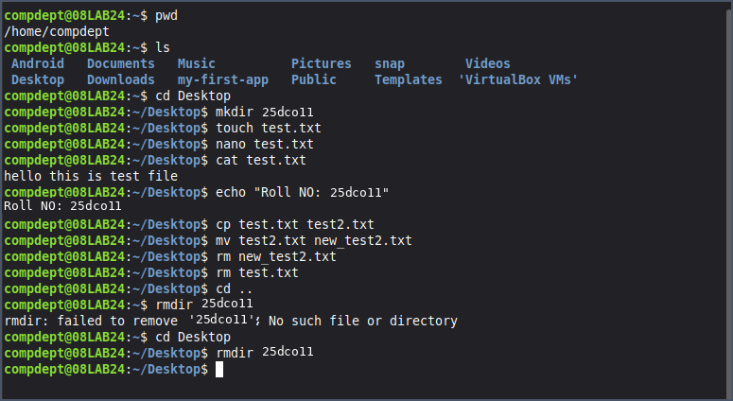
6. Error Handling Observed: -
Error: Directory Does Not Exist in Current Location
Command Executed:
rmdir 25dco11
Error Output:
rmdir: failed to remove '25dco11': No such file or directory
Reason: The command was run from the home directory (~), but the directory 25dco11 was actually created inside ~/Desktop. Since rmdir only looks in the current working directory, it could not find 25dco11 there.
Solution: Navigate into the correct parent directory first using cd Desktop, and then run rmdir 25dco11. This was verified to work successfully, as shown in Step 16 above.
7. Important Insights: -
- Commands like mkdir, touch, cd, cp, mv, and rm do not print any confirmation on success — "no output" is the expected, correct output.
- Linux commands operate relative to the current working directory unless a full/absolute path is given — this is exactly why rmdir 25dco11 failed when run from ~ instead of ~/Desktop.
- rmdir can only remove empty directories; a non-empty directory requires rm -r instead.
- echo simply prints text to the terminal, while echo "text" > file (using redirection) would instead write that text into a file.
- Using pwd frequently while navigating is a good habit — it prevents exactly the kind of location-based error seen in Step 14.
8. Result / Conclusion: -
The Linux file system hierarchy was studied, and basic file and directory operations were successfully performed using shell commands. A directory (25dco11) and a file (test.txt) were created, edited, viewed, copied, renamed and deleted using mkdir, touch, nano, cat, cp, mv and rm respectively. An error while removing the directory using rmdir was encountered and resolved by executing the command from the correct working directory, reinforcing the concept that Linux commands operate relative to the current working directory unless a full path is specified.
9. Viva Questions: -
- What is meant by the current working directory in Linux?
It is the directory in which the user is currently located within the file system, and from which relative file/directory operations are carried out. It can be checked using the pwd command.
- Which command is used to display the current directory?
The pwd (print working directory) command displays the current working directory.
- What is the difference between mkdir and touch?
mkdir creates a new, empty directory (folder) that can hold other files and directories, whereas touch creates a new, empty file (or updates the timestamp of an existing file) that can hold data/content.
- Why does the error “No such file or directory” occur?
This error occurs when a command refers to a file or directory name that does not exist in the current working directory (or the specified path). It commonly happens due to a typing mistake, deleting the file/folder earlier, or, as observed in this practical, running the command from the wrong directory.
- Which command is used to display the files and folders in the current directory?
The ls command lists all the files and folders present in the current working directory.
10. References:-
- Class practical sheet / lab manual provided by the professor : https://docs.google.com/document/d/1NBZIxKOG4weVhsjOGzZYS-olCmyzyENaNSgQydzsBF0/edit?tab=t.0

